

Software Requirements Specification
Face Recognition Attendance System
Version 1.0
Date: May 19, 2025
Prepared by:
Muhammad Talha (23-NTU-CS-1195)
Muhammad Zain Ul Abidin (23-NTU-CS-1200)
Taha Manshoor (23-NTU-CS-1213)

Approved by: Stakeholders

Table of Contents
1 Introduction 4
1.1 Purpose 4
1.2 Scope 4
1.3 Definitions, Acronyms, and Abbreviations 4
1.4 References 5
1.5 Overview 5
2 Overall Description 6
2.1 Product Perspective 6
2.2 Product Functions 7
2.3 User Classes and Characteristics 7
2.4 Operating Environment 7
2.5 Design and Implementation Constraints 8
2.6 Assumptions and Dependencies 8
3 Specific Requirements 8
3.1 Functional Requirements 8
3.2 Non-functional Requirements 9
3.3 External Interface Requirements 10
3.4 Data Requirements 11
4 Use Cases 11
4.1 Use Case: Record Attendance 11
4.2 Use Case: Generate Attendance Report 12
4.3 Use Case: Manage User Profiles 13
4.4 Use Case: Send Attendance Email 14
5 System Features 14
5.1 Feature: Facial Recognition 14
5.2 Feature: Attendance Reporting 15
5.3 Feature: User Management 15
5.4 Feature: Email Notifications 15
5.5 Feature: Audit Logging 15
5.6 Feature: Real-time Status Display 15
5.7 Feature: System Monitoring 16
6 Appendix 16
6.1 Glossary 16
6.2 Database Schema 16
6.3 Flow Diagram: 18
6.4 Sample Email Template 18
7 Index 18

Abstract
The Face Recognition Attendance System is a software solution designed to automate attendance tracking using advanced facial recognition technology, integrated with a modern Flet-based user interface and MySQL for data management. This Software Requirements Specification (SRS) document provides a comprehensive overview of the system’s functionality, including real-time attendance recording, report generation, user profile management, and automated email notifications to teachers via SendGrid. It outlines the system’s scope, constraints, and detailed requirements to guide stakeholders, including project managers, developers, and institutional administrators, in ensuring the system meets operational needs and complies with data privacy regulations.

Introduction

Purpose
This SRS document details the requirements for the Face Recognition Attendance System, a solution to automate attendance tracking using facial recognition technology, integrated with a modern Flet-based user interface and SendGrid for email notifications. It serves as a comprehensive guide for project managers, developers, testers, and stakeholders, such as school or workplace administrators, to ensure the system meets user needs and project objectives.

Scope
The FRAS automates attendance management by identifying individuals through facial recognition, recording attendance, generating reports, and notifying teachers via email. The system will:
- Capture and process facial images for attendance marking.
- Store attendance records securely in a MySQL database.
- Provide a modern, attractive Flet-based UI with a 4x2 button grid.
- Generate detailed attendance reports and analytics.
- Support user profile management for enrollment and updates.
- Allow manual attendance corrections and audit logging.
- Send attendance reports to teachers via email using SendGrid.
- Display real-time attendance status and system logs.

Definitions, Acronyms, and Abbreviations
- FRAS: Face Recognition Attendance System.
- API: Application Programming Interface.
- UI: User Interface.
- Flet: Python framework for building modern UIs.
- MySQL: Open-source relational database management system.
- CV: Computer Vision.
- SendGrid: Email delivery platform for sending notifications.

References
- IEEE Std 830-1998, IEEE Recommended Practice for Software Requirements Specifications.
- OpenCV Documentation: https://opencv.org.
- Face_Recognition_Library:https://github.com/ageitgey/face_recognition.
- Flet Documentation: https://flet.dev.
- MySQL Documentation: https://dev.mysql.com/doc.
- SendGrid Documentation: https://docs.sendgrid.com.

Overview
This document is organized as follows:
- Section 2: Describes the product’s perspective, functions, and constraints.
- Section 3: Specifies functional and non-functional requirements.
- Section 4: Details use cases for key interactions.
- Section 5: Lists system features.
- Section 6: Includes appendices with supplementary information.

Overall Description

Product Perspective
The FRAS is a standalone system with the following interfaces:
- System Interfaces: Integrates with MySQL for data storage and SendGrid for emailnotifications.
- User Interfaces: Flet-based UI with a light theme, teal-to-white gradient background, and a 4x2 grid of large, vibrant buttons (teal and pink accents).
- Hardware Interfaces: Requires a webcam or IP camera for image capture.
- Software Interfaces: Uses OpenCV, face_recognition, Flet 0.22+, mysql-connector-python for MySQL, SendGrid Python library, and Flask for optional API services.
- Communication Interfaces: TCP/IP for MySQL; HTTPS for SendGrid API and potential remote access.
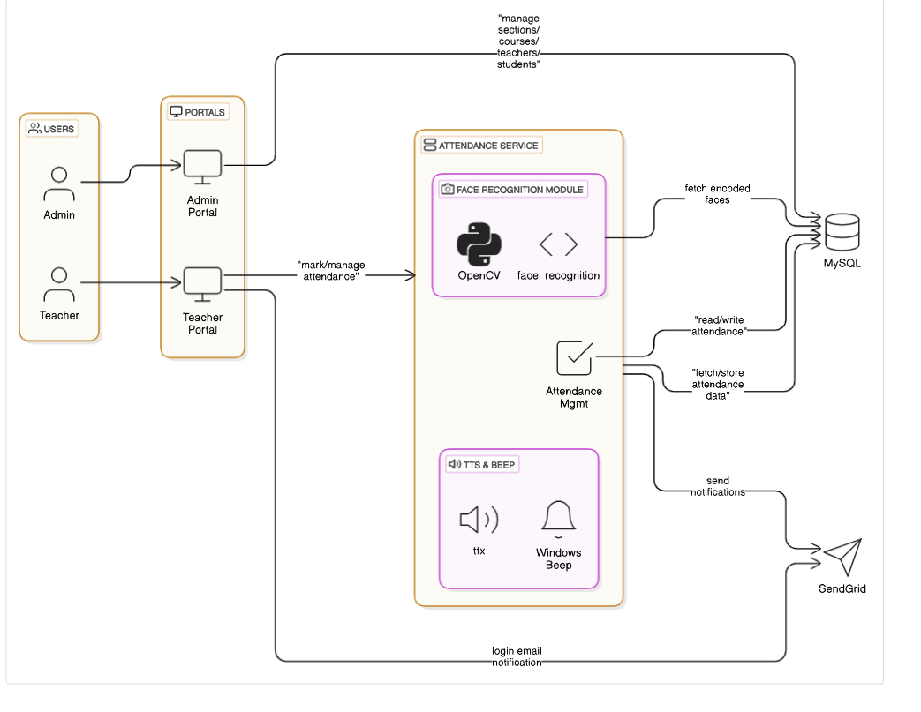
Figure 1

Product Functions
- Capture facial images via camera for attendance.
- Identify individuals using facial recognition algorithms.
- Record attendance with timestamps in MySQL.
- Generate daily, weekly, monthly, and custom attendance reports.
- Allow admins to manually correct attendance records.
- Manage user profiles (add, update, delete) with facial images and email addresses.
- Log administrative actions for audit purposes.
- Export reports in PDF and CSV formats.
- Send attendance reports to teachers via email using SendGrid.
- Provide real-time attendance status display in the UI.
- Monitor system performance and log errors.

User Classes and Characteristics
- Administrators: Manage profiles, attendance, reports, email settings, and system con-figuration via the Flet UI. Require basic computer skills and minimal training (1 hour).
- End-Users: Students whose attendance is recorded. No technical skills needed, only face the camera.
- Teachers: Receive attendance reports via email. Require email access and basic digital literacy.
- System Maintainers: Monitor system performance and resolve errors. Require Python and MySQL expertise.

Operating Environment
- Hardware: PC with a camera, minimum 8GB RAM, 2GHz processor, 1GB storage fordatabase and images.
- Software: Windows, Python 3.9, OpenCV 4.5+, face_recognition, Flet 0.22+,mysql-connector-python, MySQL 8.0, SendGrid Python library.
- Network: Local network for MySQL; stable internet for SendGrid email delivery.

Design and Implementation Constraints
- Dependent on camera quality (minimum 1080p, 30 FPS) and lighting.
- Requires Python 3.9 for face_recognition and dlib compatibility.
- Flet UI must maintain a 4x2 button grid with teal/pink color scheme.
- MySQL database must support concurrent access for up to 50 users.
- SendGrid API key must be securely configured.

Assumptions and Dependencies
- Assumes consistent lighting and camera positioning for recognition.
- Assumes users are enrolled with high-quality facial images.
- Assumes teachers have valid email addresses in the system.
- Depends on OpenCV, face_recognition, Flet, mysql-connector-python, MySQL, andSendGrid.
- Requires Visual Studio Build Tools and CMake for dlib installation.
- Assumes MySQL server is locally hosted or accessible with latency under 50ms.
- Assumes SendGrid account is active with sufficient email credits.

Specific Requirements

Functional Requirements

ID | Requirement | Priority | Stakeholder
FR-001 | The system shall capture a user’s facial image in real time using the connected camera device. | Must Have | Stakeholder
FR-002 | The system shall compare the captured facial image with stored facial profiles to identify the user. | Must Have | Stakeholder
FR-003 | The system shall automatically record the identified user's attendance along with the exact timestamp. | Must Have | Stakeholder
FR-004 | The system should allow users to generate attendance reports for a selected date or date range. | Should Have | Stakeholder
FR-005 | The system may provide admins with the ability to manually correct attendance records when needed. | Could Have | Admin
FR-006 | The system shall enable admins to add, update, or delete teacher profiles, including their associated emails. | Must Have | Admin
FR-007 | The system should log all administrative actions such as profile changes and attendance edits for auditing. | Should Have | Auditor
FR-008 | The system should support exporting attendance reports in both PDF and CSV file formats. | Should Have | Stakeholder
FR-009 | The system may display real-time attendance status for each class or session to the admin dashboard. | Could Have | Admin
FR-010 | The system should automatically send attendance reports to teachers via their registered email addresses. | Should Have | Stakeholder
FR-011 | The system may allow admins to configure and customize email templates used for attendance notifications. | Could Have | Admin
FR-012 | The system should log the delivery status of each email, including success or failure details. | Should Have | Admin
FR-013 | The system may generate detailed error logs whenever system failures or exceptions occur. | Could Have | Maintainer

Non-functional Requirements
ID | Category | Requirement
NFR-001 | Performance | The system shall complete facial recognition within 10 seconds.
NFR-002 | Performance | The UI shall load completely within 3 seconds.
NFR-003 | Performance | The system shall generate reports within 5 seconds.
NFR-004 | Performance | The system shall send emails within 5 seconds.
NFR-005 | Usability | The system shall provide a modern, intuitive Flet UI with large buttons, teal accents, and clear fonts.
NFR-006 | Usability | The system should require no more than 5 minutes of training for end users.
NFR-007 | Reliability | The system shall maintain a minimum uptime of 99.5%.
NFR-008 | Reliability | The system shall recover MySQL data within 1 hour after a failure.
NFR-009 | Reliability | The system shall achieve an email delivery success rate of over 98%.
NFR-010 | Security | The system shall enforce role-based user authentication.
NFR-011 | Security | The system shall securely store SendGrid API keys.
NFR-012 | Security | The system shall sanitize email inputs to prevent injection attacks.
NFR-013 | Scalability | The system shall support up to 5,000 registered users.
NFR-014 | Scalability | The system shall handle at least 50 concurrent users without performance degradation.
NFR-015 | Compatibility | The system shall be compatible with Python 3.9, Flet 0.22+, MySQL 8.0, and SendGrid API.
NFR-016 | Availability | The system shall be accessible 24/7.
NFR-017 | Availability | Scheduled maintenance downtime shall not exceed 1 hour per month.
NFR-018 | Maintainability | The codebase shall be modular and fully documented.
NFR-019 | Maintainability | Feature updates and bug fixes shall be completed within 2 weeks of reporting.
NFR-020 | Portability | The system shall be deployable on Windows and Linux with minimal setup.
NFR-021 | Interoperability | The system shall integrate seamlessly with MySQL for data and SendGrid for email services.
NFR-022 | Accessibility | The UI shall support high-contrast mode to enhance visibility for all users.

External Interface Requirements
- User Flet-based UI with a 4x2 grid layout of teal rounded buttons on a teal-to-dark gradient background, featuring white icons and labels. Centered bold title ("Face Recognition Attendance System") with a subtitle. Buttons include: Train Data, Student Details, Teacher Details, Course Details, Section Details, Enrollment Details, Exit, using clean sans-serif typography for a modern, professional look.
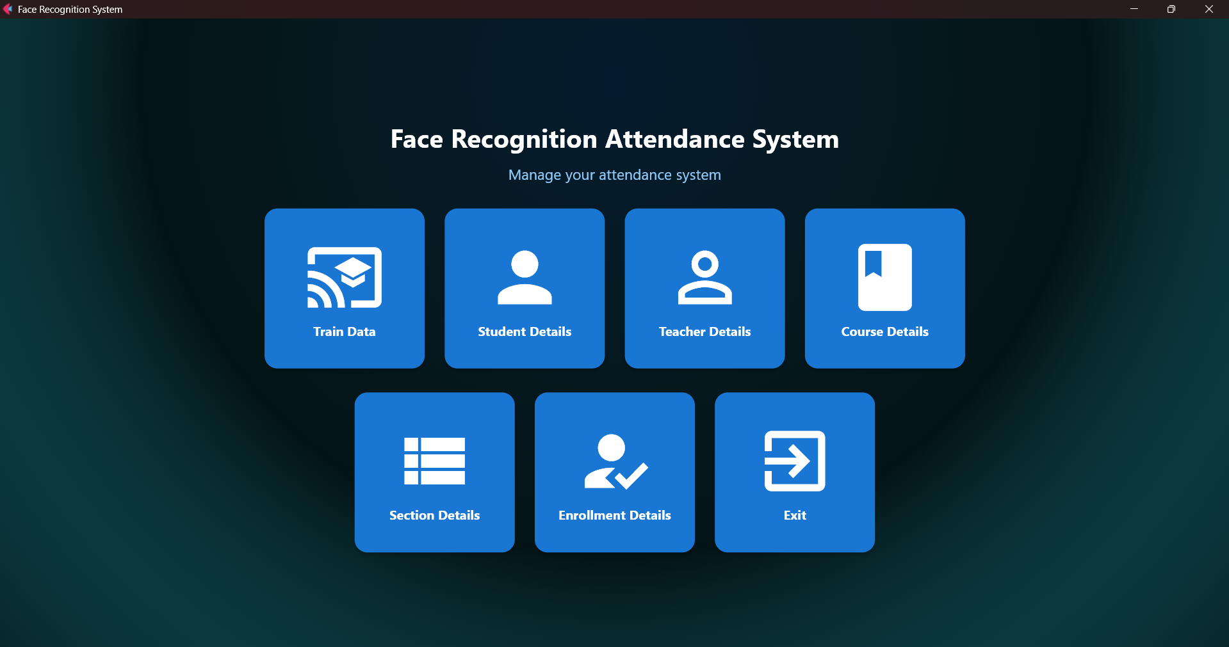
Figure 2 UI Dashboard
- Hardware Interfaces: Webcam or IP camera with 1080p resolution, minimum 30 FPS.
- Software Interfaces: OpenCV 4.5+, face_recognition, Flet 0.22+, mysql-connector-python, MySQL 8.0, SendGrid Python library, Flask for optional API.

Data Requirements
- Data Formats: JPEG for images (max 2MB), MYSQL tables for saving system records.
- Data Retention: Store data for 7 years; archive annually to secondary storage.
- Data Integrity: Ensure transactional consistency for attendance, email, and audit records.
- Data Backup: Daily MySQL backups with 30-day retention.

Use Cases

Use Case: Record Attendance

Use Case Name | Record Attendance
XRef | Section 3.1, Capture Photo; Section 3.2, Attendance Logs; SDD Section 5.1
Trigger | The teacher selects the "Capture Photo" option in the Flet-based UI.
Precondition | - Student is enrolled in the system  - Camera is operational
Basic Path | 1. Teacher selects "Capture Photo".  2. Student faces the camera.  3. System captures and processes the image.  4. System matches image to student profile.  5. System records attendance in MySQL.  6. System updates the real-time status display.
Alternative Paths | A1 Recognition Failure:  Prompt for retry or allow manual entry.  A2 – Camera Failure:  Display error and enable manual entry.
Postcondition | Attendance is successfully recorded in the MySQL database with a timestamp.
Exception Paths | The process may be aborted if no face is detected or the camera crashes.
Other | None

Use Case: Generate Attendance Report

Use Case Name | Generate Attendance Report
XRef | Section 3.3, View Reports; Section 3.4, Export Functionality; SDD Section 5.2
Trigger | The teacher selects "View Reports" in the Flet-based UI.
Precondition | Attendance data is available in the MySQL database.
Basic Path | - Teacher selects "View Reports".  - Teacher specifies report period (daily/custom).  - System queries MySQL for matching attendance data.  - System displays report with summary stats in UI.5. Teacher exports the report as PDF or CSV.
Alternative Paths | If no data is found for the selected period, the system shows a “No Records” message.
Postcondition | Attendance report is generated and made available for download.
Exception Paths | If the database is unreachable or export fails, an error message is shown.
Other | PDF/CSV formats supported

Use Case: Manage User Profiles
- Title: Manage User Profiles
Use Case Name | Manage User Profiles
XRef | Section 3.5, Manage Users; SDD Section 5.3
Trigger | The administrator selects "Manage Users" in the Flet-based UI.
Precondition | Administrator is authenticated and has access privileges.
Basic Path | - Administrator selects "Manage Users".  - Chooses to add, update, or delete a user.  - System prompts for details (name, Reg_No, email, facial image).  - System validates input (e.g., email format, unique Reg_No).  - 5. System updates the MySQL database and logs the action.
Alternative Paths | - If image is invalid or unreadable, prompt user to upload a new image.  - If Reg_No or email is already in use, display a duplication error message.
Postcondition | User profile is successfully added, updated, or deleted in the MySQL database.
Exception Paths | If validation fails or database update encounters an error, notify the user.
Other | All actions are logged for audit purposes.

Use Case: Send Attendance Email

Use Case Name | Send Attendance Email
XRef | Section 3.6, Email Reports; SDD Section 5.4
Trigger | The teacher selects "Send Emails" in the Flet-based UI.
Precondition | Attendance data exists in MySQL; teacher's email is properly configured.
Basic Path | - Teacher selects "Send Emails".  - Chooses a report period.  - System queries MySQL for data.  - System formats the report with email template.  - System sends the email via SendGrid API.  - System logs the delivery status in MySQL.
Alternative Paths | - If SendGrid fails, system retries once and notifies the admin.  - If no data found, show “No Records” message.  - If email is invalid, flag the user for correction.
Postcondition | Email sent to the teacher and delivery status logged in the database.
Exception Paths | If sending fails after retry, display failure message and log issue.
Other | Email template is customizable; supports HTML formatting.

System Features

Feature: Facial Recognition
- Description: Identifies users using face_recognition library with dlib-based face encod-ings.
- Functional Requirements: FR-001, FR-002.
- Non-functional Requirements: Process in under 2 seconds, 95% accuracy under optimallighting, handles occlusions (e.g., glasses).

Feature: Attendance Reporting
- Description: Generates detailed reports via Flet UI, with visualizations (e.g., atten-dance trends), exportable to PDF/CSV.
- Functional Requirements: FR-004, FR-008.
- Non-functional Requirements: Loads in under 5 seconds, vibrant UI with clear charts.

Feature: User Management
- Description: Manages user profiles with facial images, emails, and roles in MySQL.
- Functional Requirements: FR-006, FR-009.
- Non-functional Requirements: Secure access, operations in under 3 seconds, supportsbatch updates.

Feature: Email Notifications
- Description: Sends attendance reports to teachers via SendGrid with customizabletemplates.
- Functional Requirements: FR-011, FR-012, FR-013.
- Non-functional Requirements: Delivery within 10 seconds, supports HTML emails,logs delivery status.

Feature: Audit Logging
- Description: Logs administrative actions for compliance and troubleshooting.
- Functional Requirements: FR-007.
- Non-functional Requirements: Logs accessible within 3 seconds, tamper-proof storage,exportable to CSV.

Feature: Real-time Status Display
- Description: Displays current attendance status and system metrics in the Flet UI.
- Functional Requirements: FR-010.
- Non-functional Requirements: Updates in under 1 second, integrates with 4x2 grid,clear visuals.

Feature: System Monitoring
- Description: Tracks system performance (CPU, memory) and logs errors for mainte-nance.
- Functional Requirements: FR-014, FR-015.
- Non-functional Requirements: Metrics refresh every 5 seconds, logs stored for 90 days.

Appendix

Glossary
- Facial Recognition: Technology for identifying individuals via facial features.
- Flet: Python framework for modern, cross-platform UIs.
- MySQL: Relational database for storing profiles, attendance, and logs.
- SendGrid: Platform for sending email notifications.
- Audit Log: Record of administrative actions for compliance.
- Face Encoding: Numerical representation of facial features.

Database Schema
- Teacher: (Teacher_ID, Username, Password , Email, Phone)
- Student: (Roll_NO, Full_Name, Section_ID, PhotoSample)
- Course: (Course_ID, CourseCode, CourseName, CreditHours)
- Enrollment: (Teacher_ID, Section_ID, Course_ID)
- Attendance: (Attendance_ID, Roll_NO, Course_ID, Teacher_ID, Section_ID, Date, Time, Status [Present/Absent])
- Section: (Section_ID, Name, Deaprtment, Semester)

Flow Diagram:
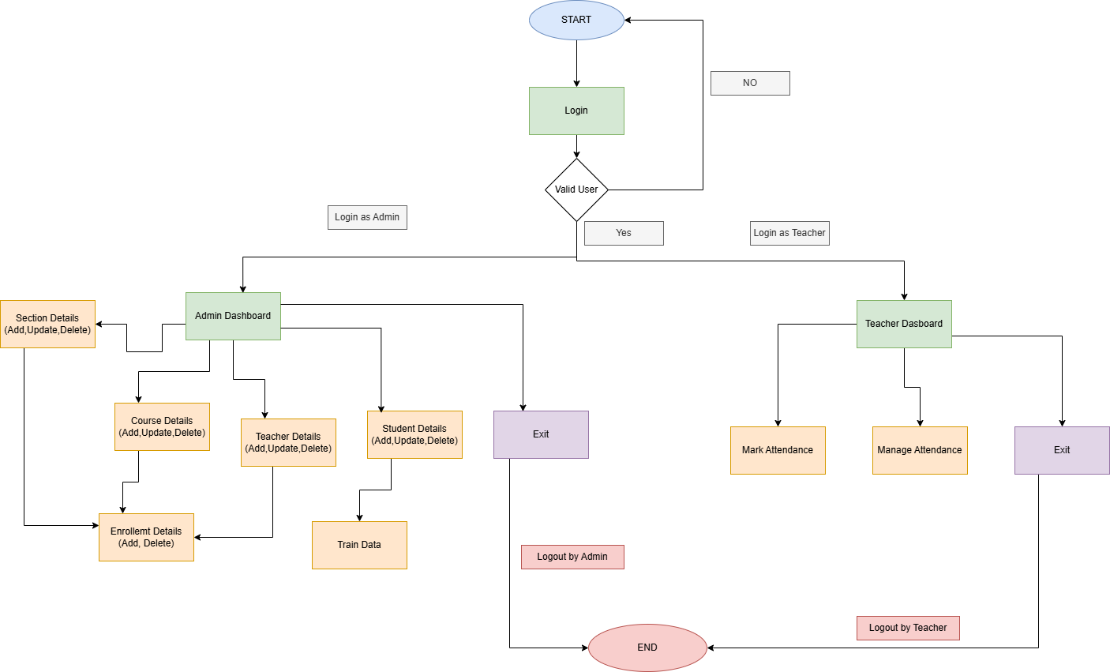

Sample Email Template
Subject: Attendance Report for [Period]
Dear [Teacher Name],
Attached is the attendance report for [Period]. Summary:
- Total Students: [Number]
- Present: [Number]
- Absent: [Number]
Please review the attached PDF for details.
Regards,
FRAS Team

Index
- Facial Recognition: Section 5.1
- Attendance Reporting: Section 5.2
- User Management: Section 5.3
- Email Notifications: Section 5.4
- Audit Logging: Section 5.5
- Real-time Status: Section 5.6
- System Monitoring: Section 5.7
- Flet UI: Section 3.3
- MySQL: Section 2.1
- SendGrid: Section 5.4

